This document is meant to explain, in explicit detail, how the Soda Elevator/Carrying System (SECS) works. It is provided so that someone in the future will be able to perform maintenance on SECS.

First, a schematic:

Figure 1: The schematic

As you can see, there are three push-button momentary switches and one whisker switch. The whisker switch detects when a can is present. The momentary switch at the bottom of the diagram is active when the can is at the bottom of the elevator. The momentary switch at the top of the diagram and facing downward is active when the can is at the top of the elevator. The momentary switch near the top of the diagram and facing up is active when someone presses the reset button to let Heroine know it needs to return to Drink and accept the next soda.

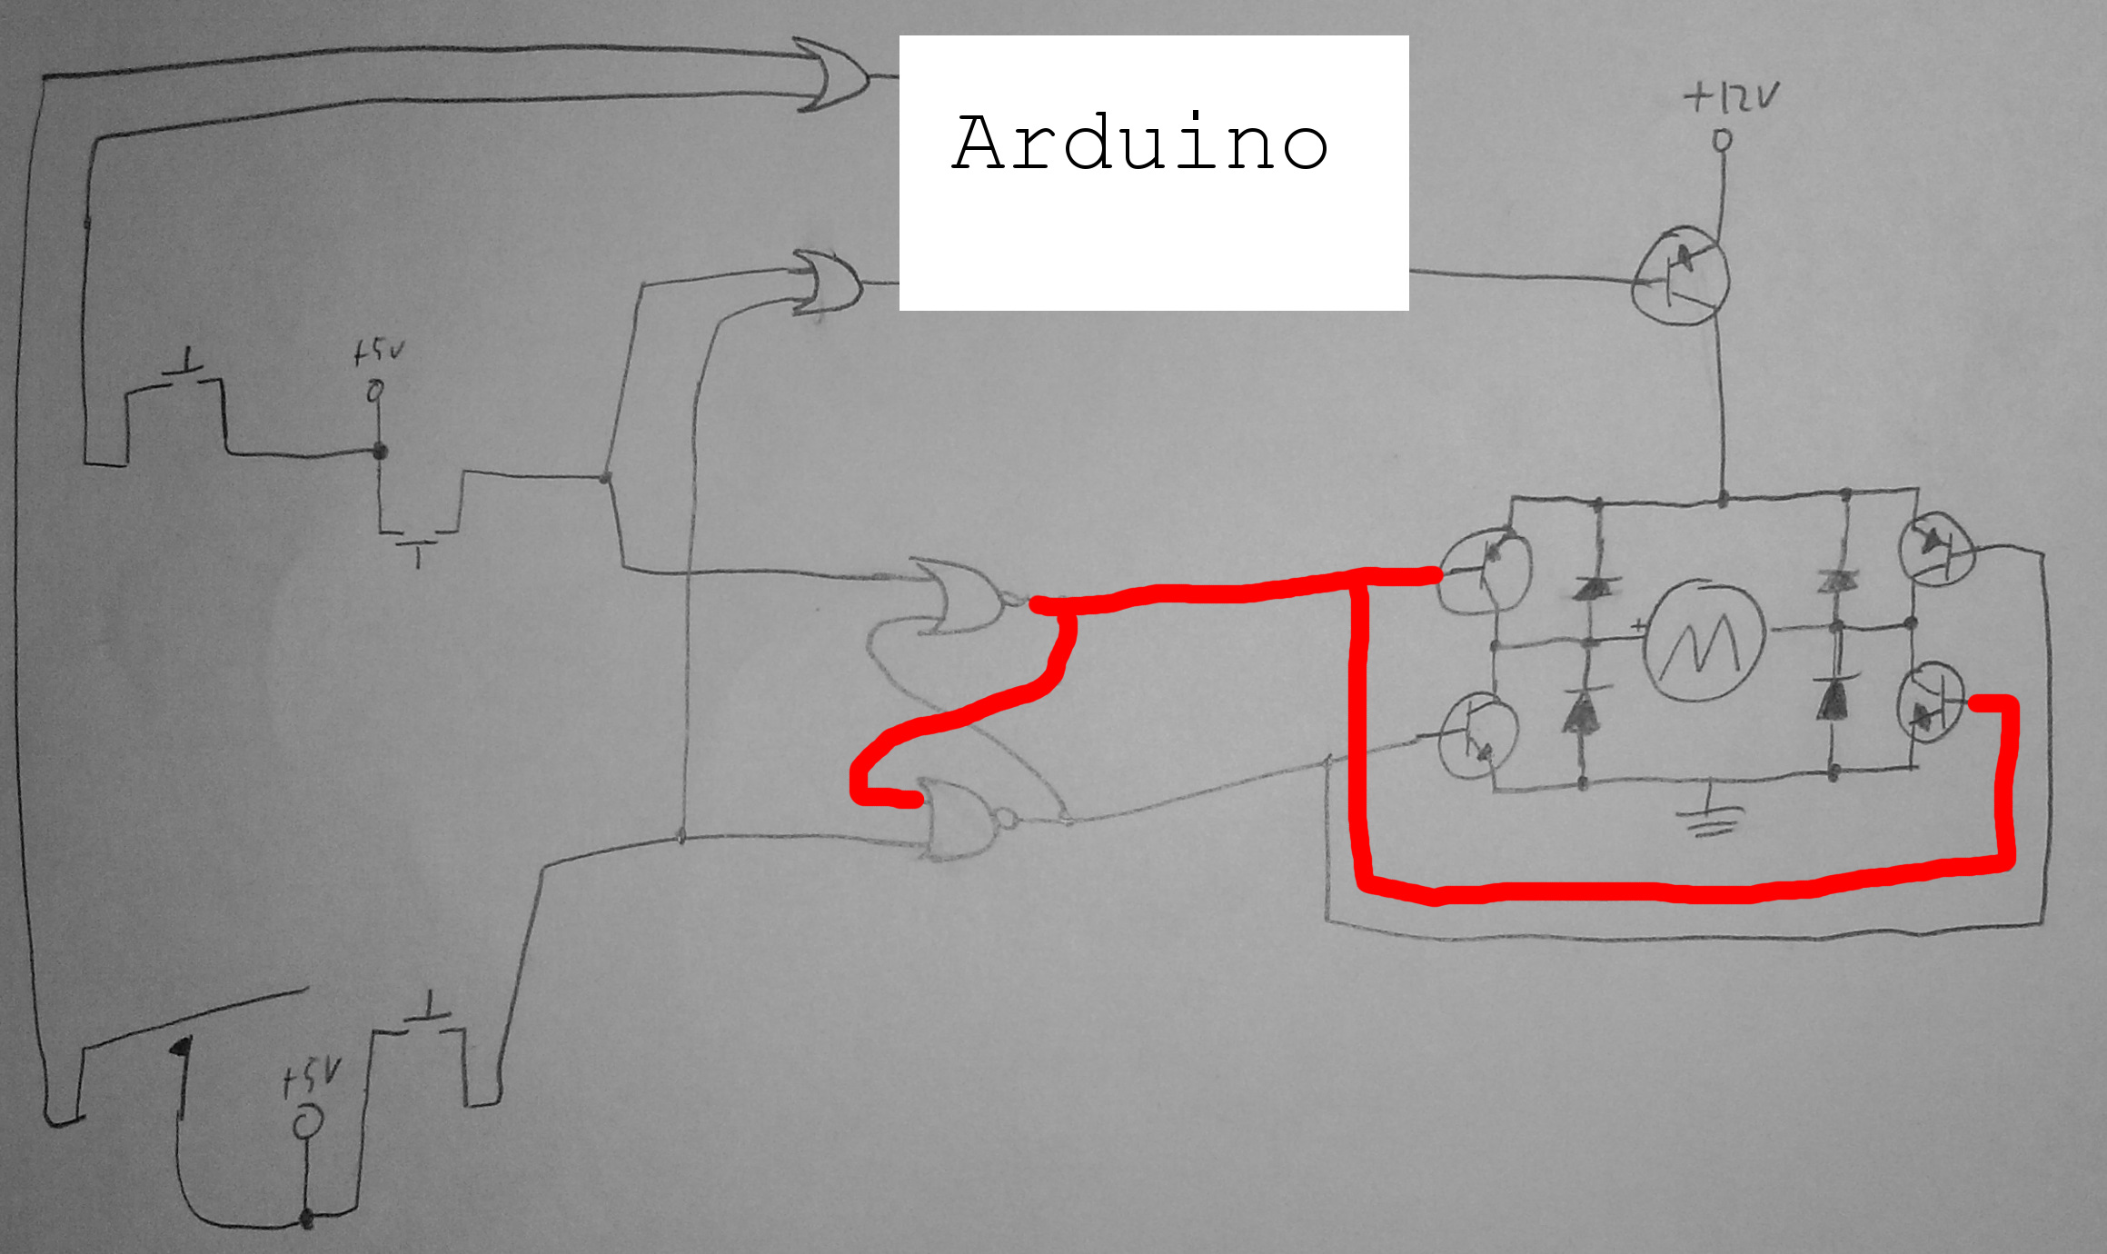
Figure 2 shows Heroine in her default state:
Figure 2: Heroine in her default state

As one can see, Heroine is ready to move forward.

Now, suppose someone order a drink, and it lands in the elevator. Heroine's circuity will appear like this:
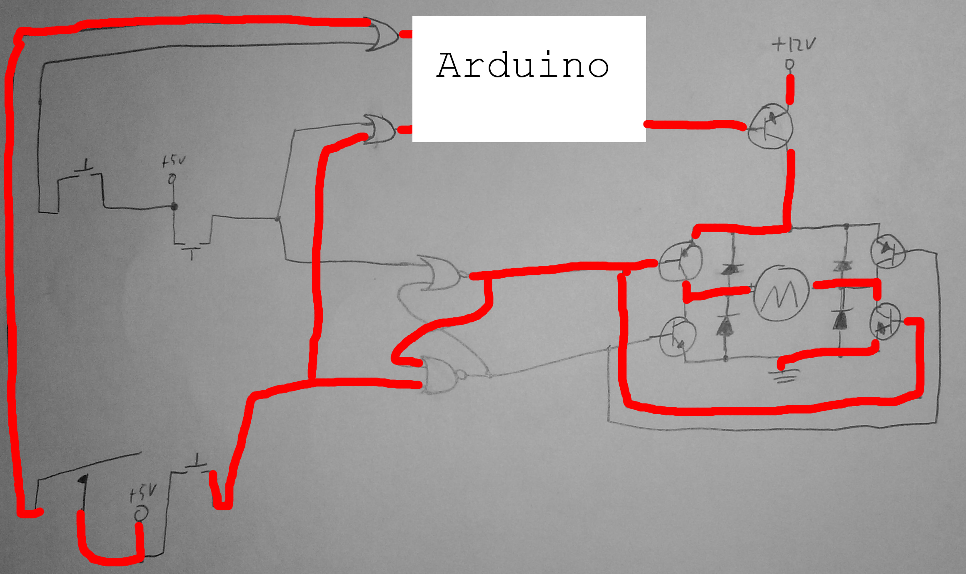
Figure 3: Heroine after a drink drops

The drink drops down and activates the whisker switch. This tells the Arduino to let the motor run (as it will track the changes in inputs rather than the state of the inputs), raising up the elevator. Eventually, the elevator reaches the top of its shaft. Heroine's circuitry then looks like this:

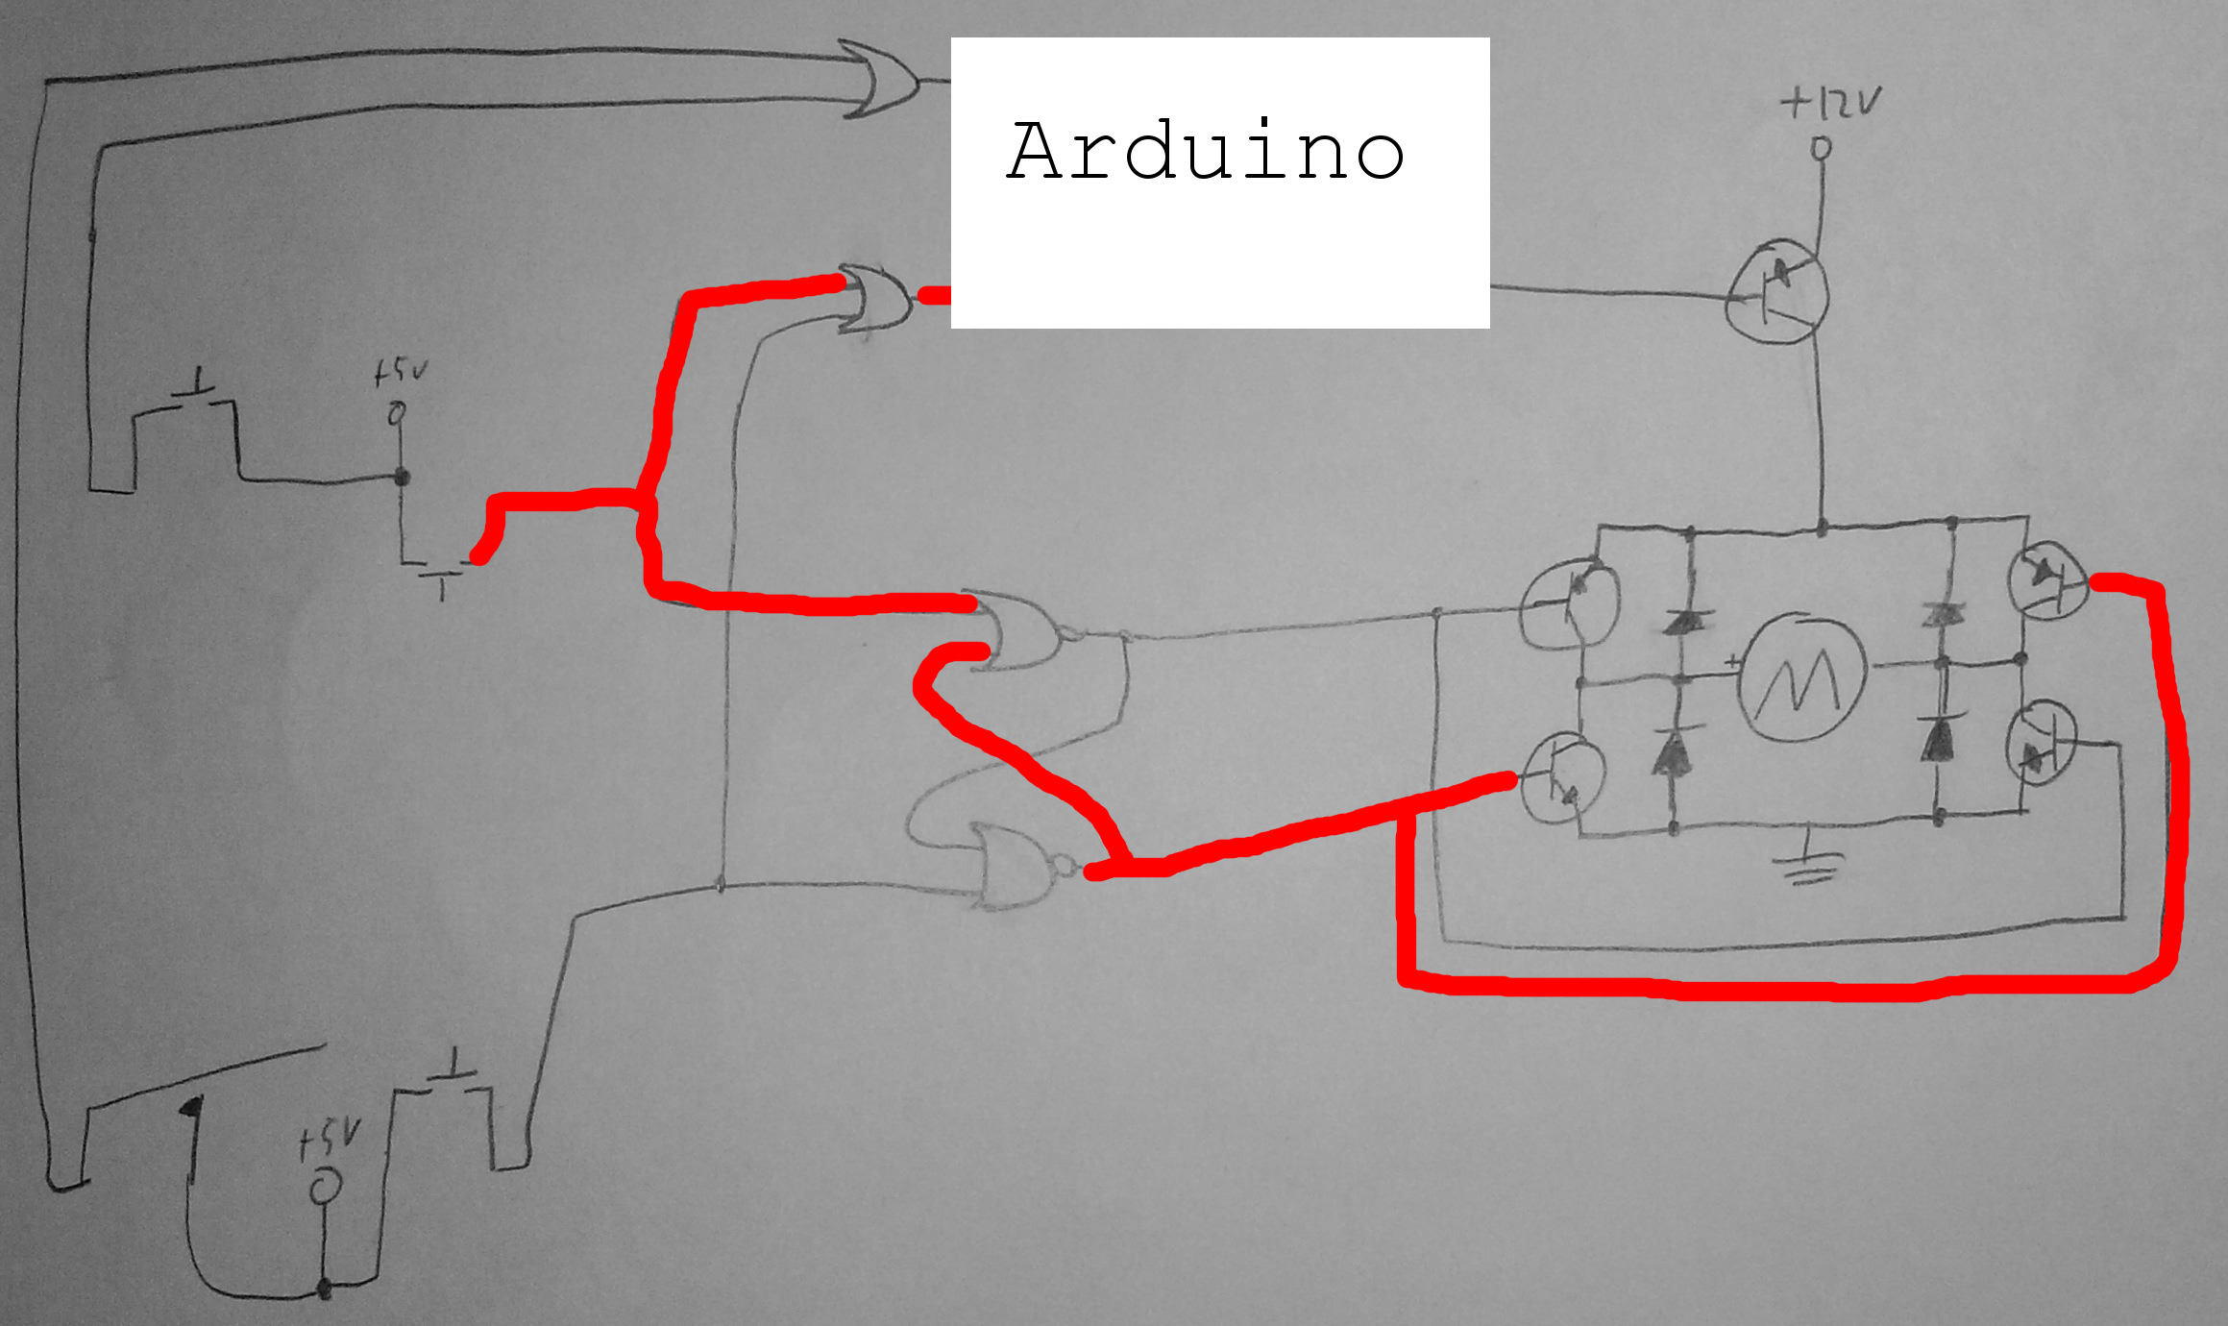
Figure 4: Heroine when the elevator is at its maximum height

The elevator carriage hits the top momentary switch. This does two things. It changes the state of the bottom SR latch, setting Q to low and Q-not to high. This sets the elevator up to move downward, and the motor will now rotate in the opposite direction. The top momentary switch also tells the Arduino to stop the motor, which it does. The drink is now ready to be taken by some CSHer.

Said CSHer takes his/her drink and presses the reset switch. Heroine's circuitry now looks like this:
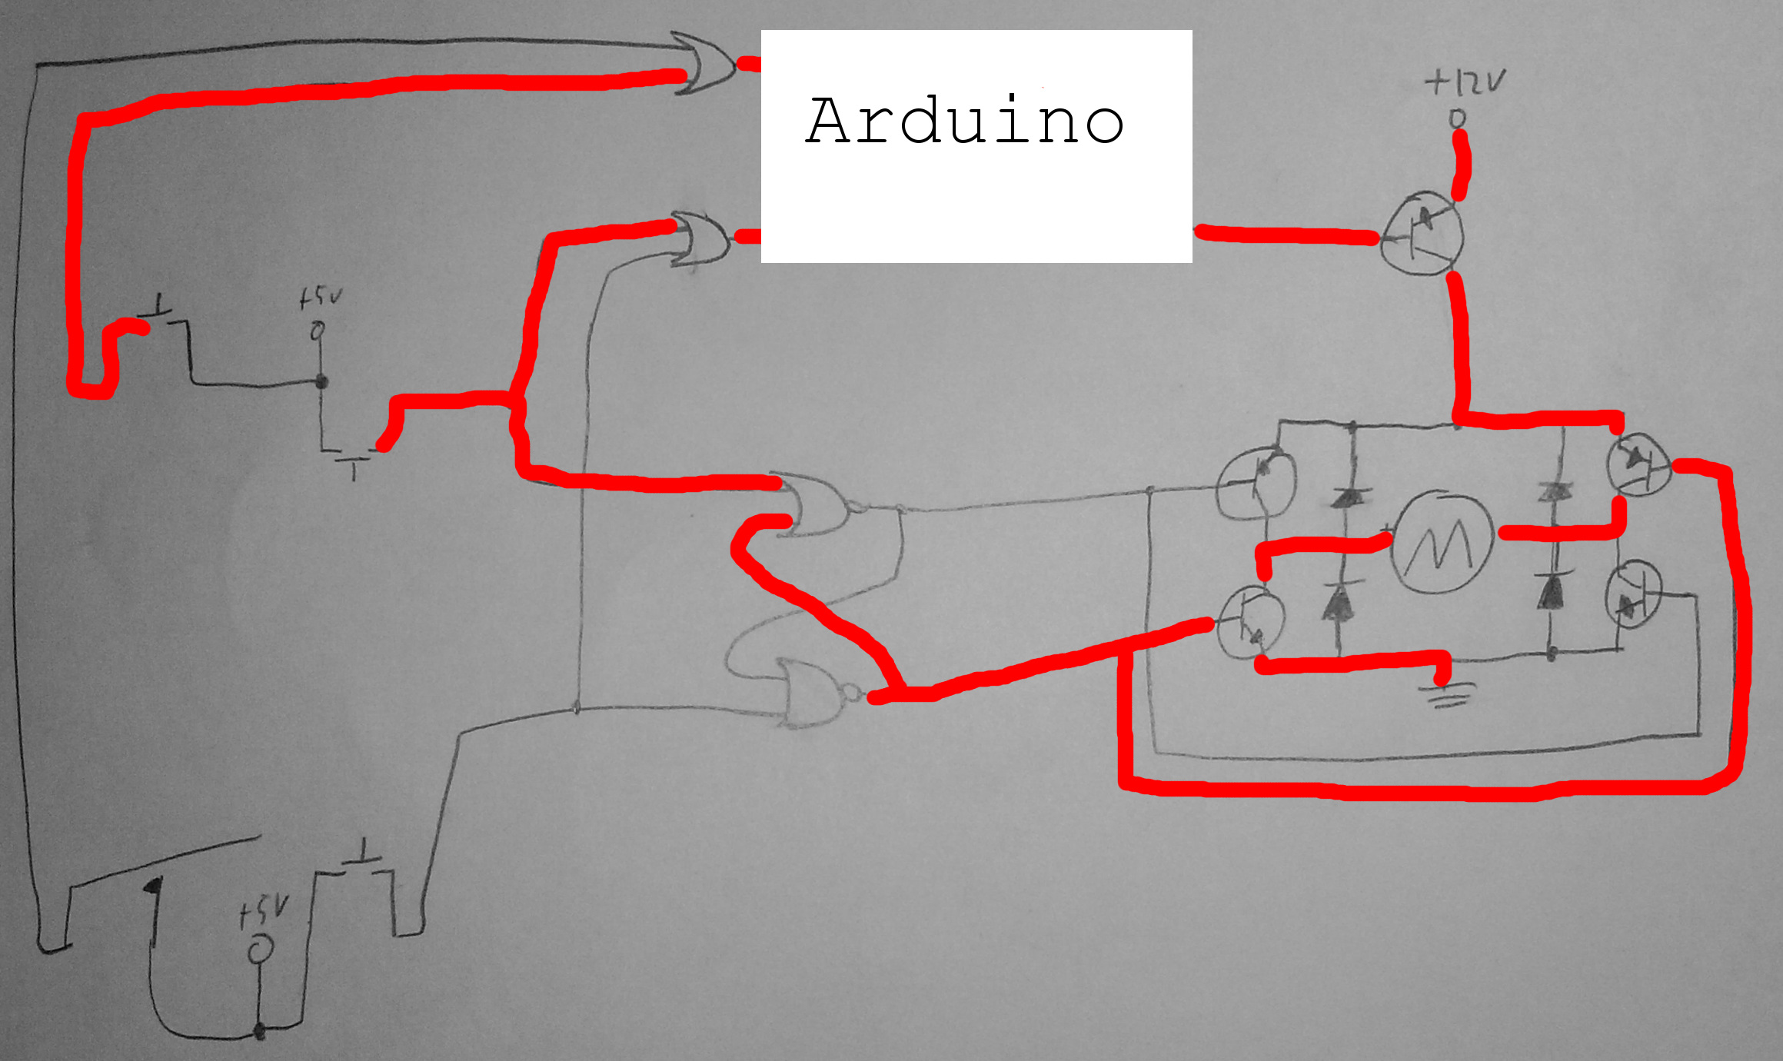
Figure 5: Heroine after the reset switch has been pressed

The motor turns backwards, so the elevator lowers until the bottom switch is hit. The elevator is now in its default position, ready for the next drink.

Please see the Arduino code, found at https://github.com/DethRaid/Heroine for details on how exactly that works

